**User Manual**

**1. Overview**

1. After downloading and unzipping the folder “JunRong_FaceRecognition (BACS3074 AI)”, you may now proceed to pycharm and select this folder to open.
2. This zip folder consists of a few important folders. However, we will only focus on two main folders which are **dataset folder** and **venv folder**. Under the dataset folder, there are 3 sub-folders such as Jun_Rong, Ming_Jun and unknown. All the datasets/images are placed in each of the folder accordingly. (You may remove all the datasets and upload your own datasets/faces – Refer to Pg10 and 11)
3. While under the venv folder, there are 3 important python files such as **extract_embeddings.py**, **recognize_video.py** and **train_model.py**.

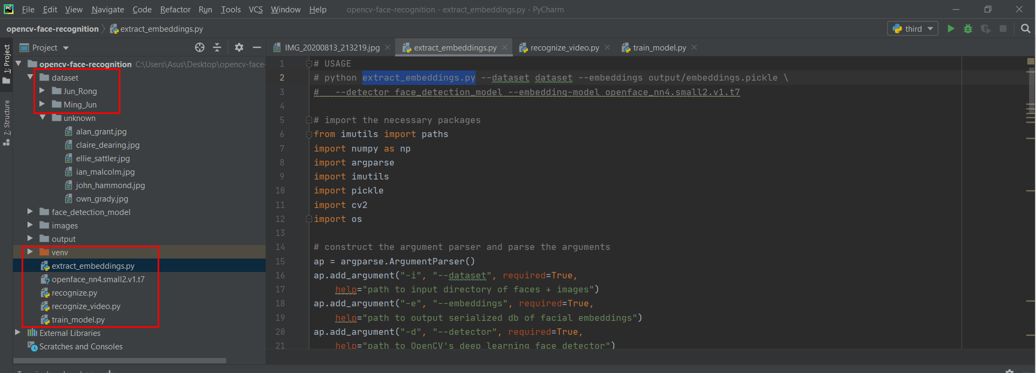

**2. Install Package**

1. Click File > Settings

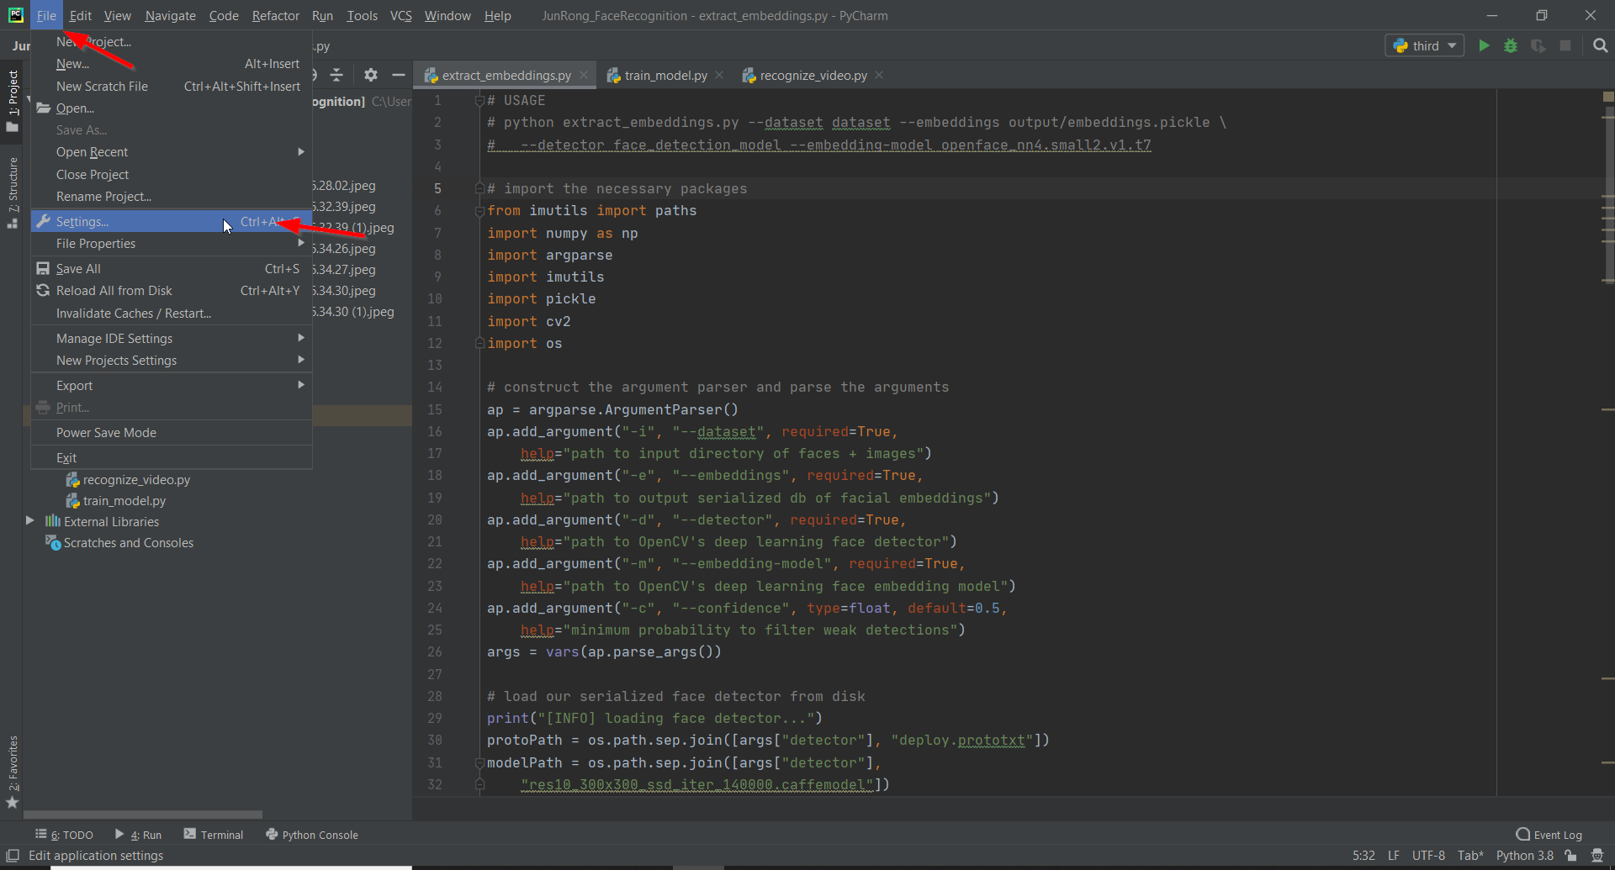

1. Click Project: JunRong_FaceRecognition > Project Interpreter > ‘+’ (on the right-hand side)

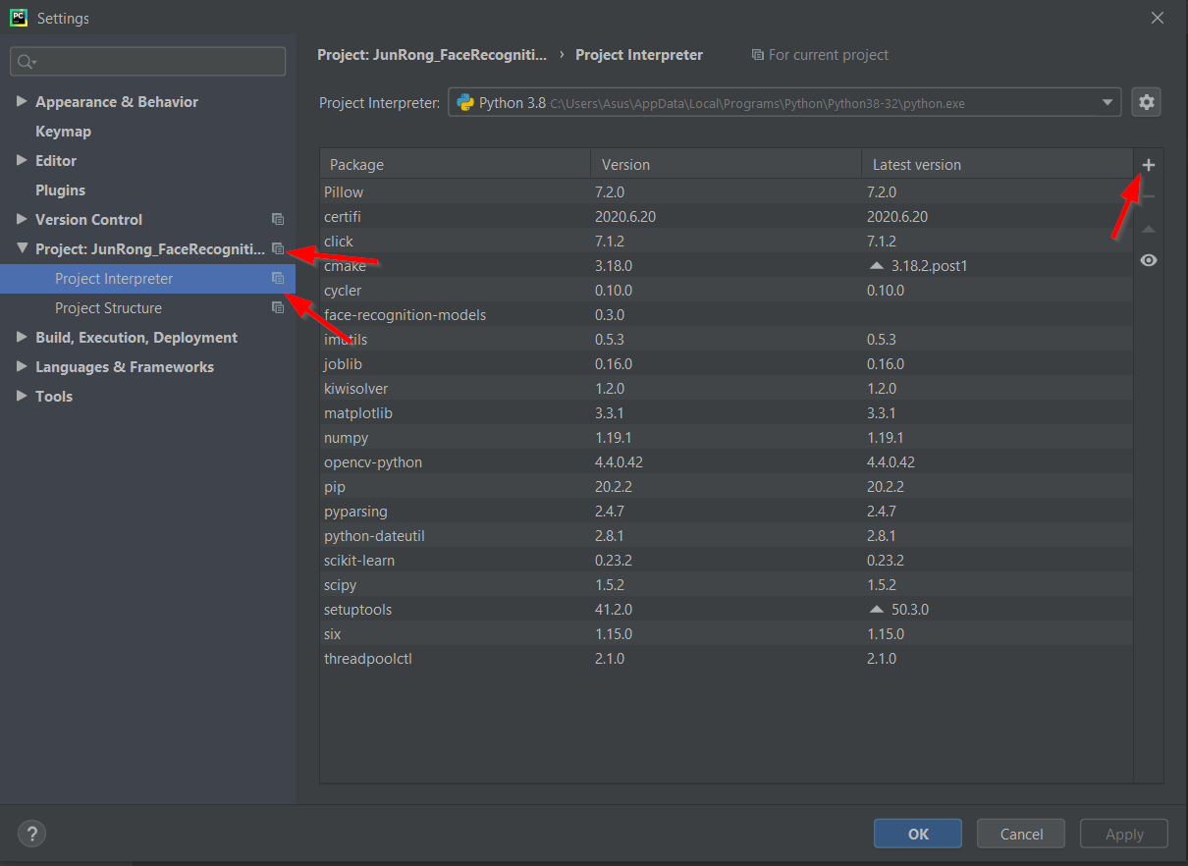

1. Search the package name.
2. Select the correct package.
3. Select the correct version.
4. Click “Install Package”.

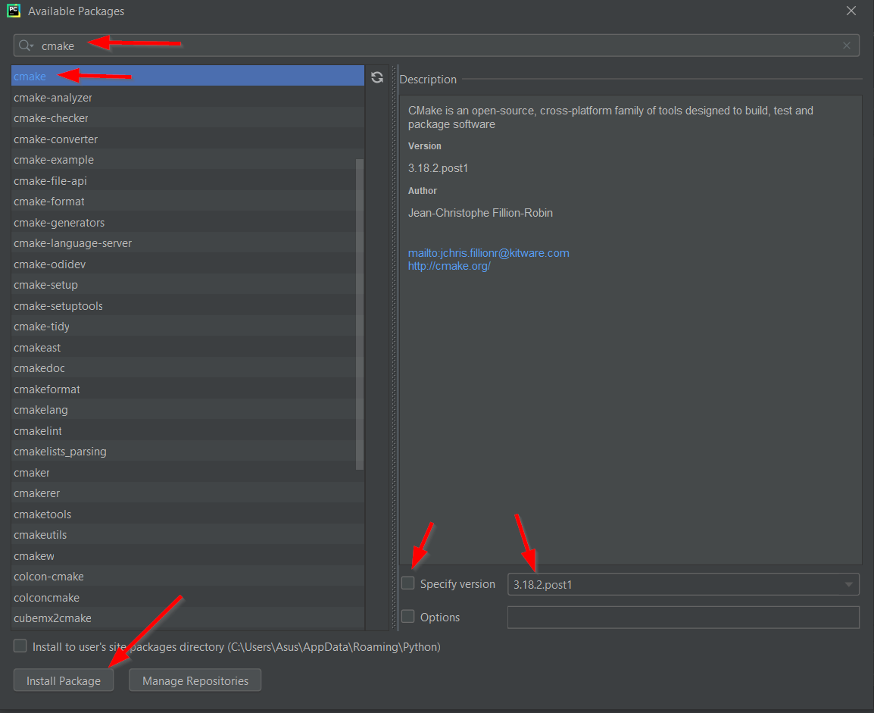

**NOTE:**

List of packages to be installed:

1. dlib (version 19.18.0) 9. Pillow (default version)
2. face-recognition (default version) 10. Imutils (default version)
3. numpy (default version) 11. Threadpoolctl (version 2.1.0)
4. opencv-python (default version)
5. cmake (default version)
6. sklearn (default version)
7. scikit-learn (default version)
8. scipy (default version)

**3. Execute/Run the program**

1. Open all the 3 python files by double clicking each of the file.
2. Click Run > Edit Configuration

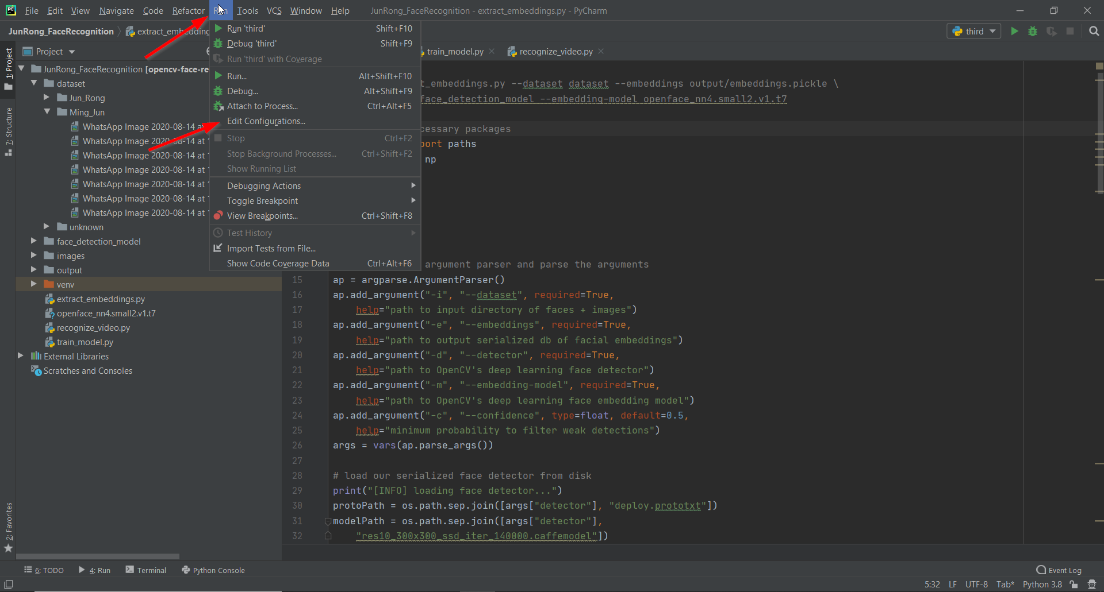

3.1 extract_embeddings.py:

1. Enter “first” in the name column.
2. Select the path with the file “extract_embeddings.py”.
3. Copy and paste this command in the parameters column:

--dataset dataset --embeddings output/embeddings.pickle --detector face_detection_model --embedding-model openface_nn4.small2.v1.t7

1. Click Apply.

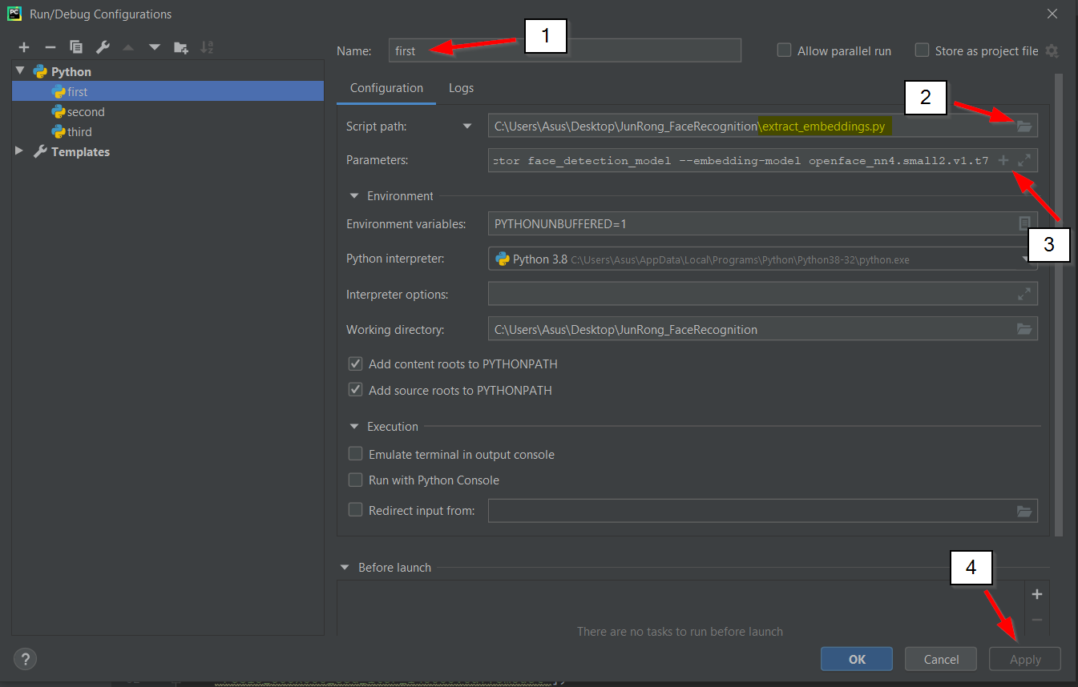

3.2 train_model.py:

1. Enter “second” in the name column.
2. Select the path with the file “train_model.py”.
3. Copy and paste this command in the parameters column:

--embeddings output/embeddings.pickle --recognizer output/recognizer.pickle --le output/le.pickle

1. Click Apply.

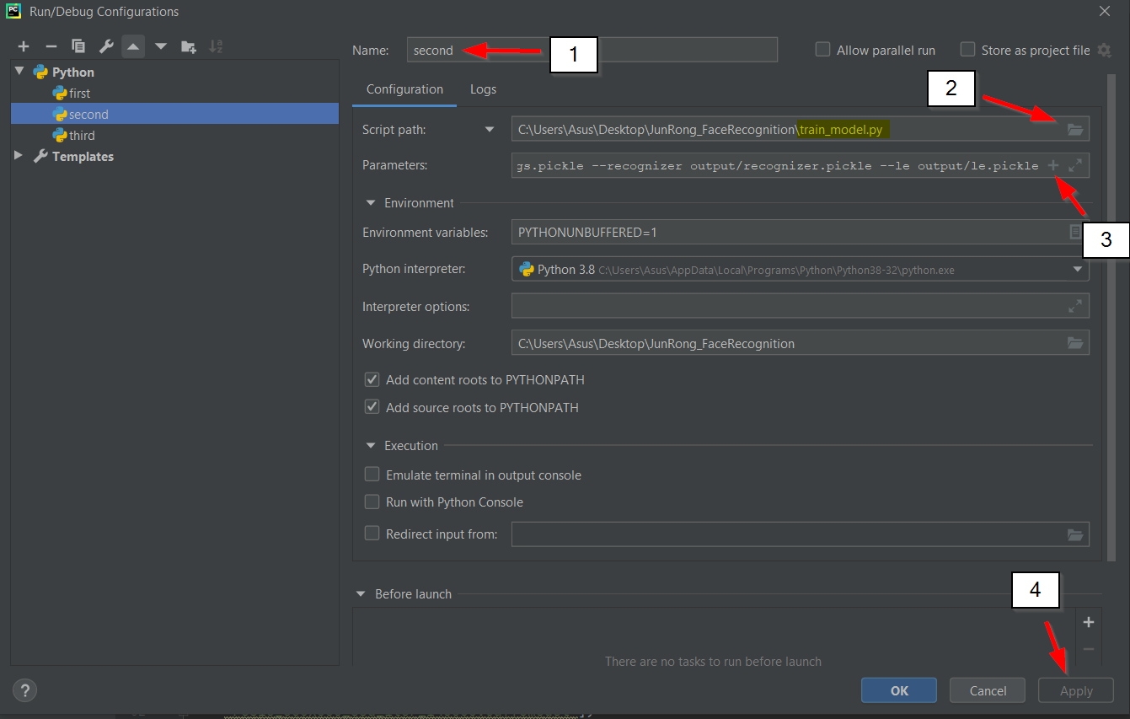

3.3 recognize_video.py:

1. Enter “third” in the name column.
2. Select the path with the file “recognize_video.py”.
3. Copy and paste this command in the parameters column:

--detector face_detection_model --embedding-model openface_nn4.small2.v1.t7 --recognizer output/recognizer.pickle --le output/le.pickle

1. Click Apply.
2. Click OK.

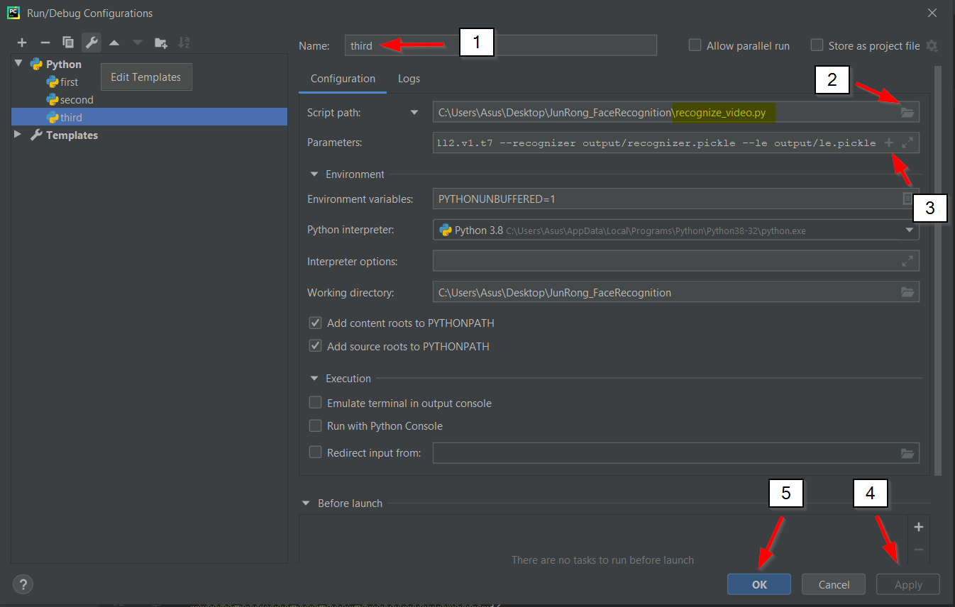

After editing the configuration, you may now start to execute the program.

3.4 first

1. Select first.
2. Click the run button.

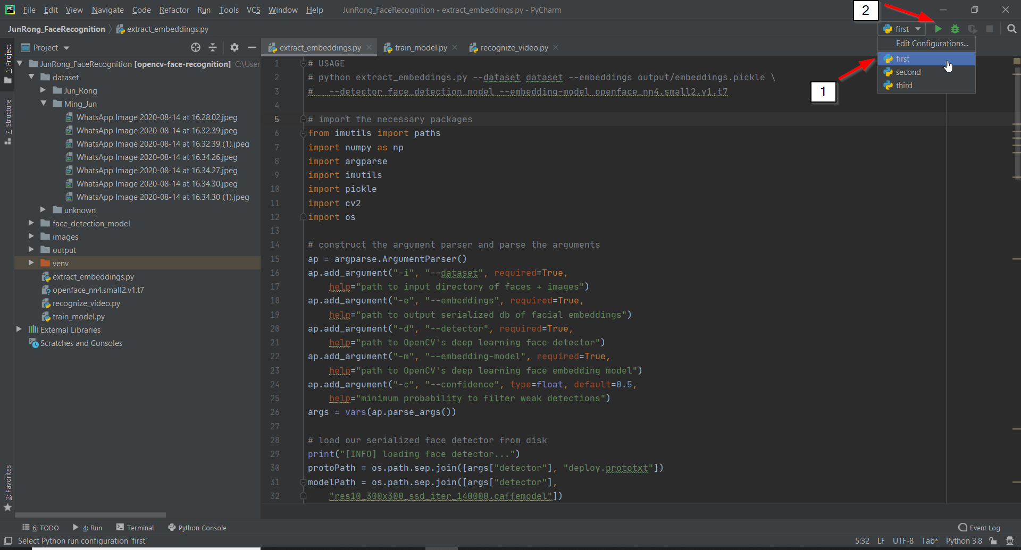

3.4 second

1. Select second.
2. Click the run button.

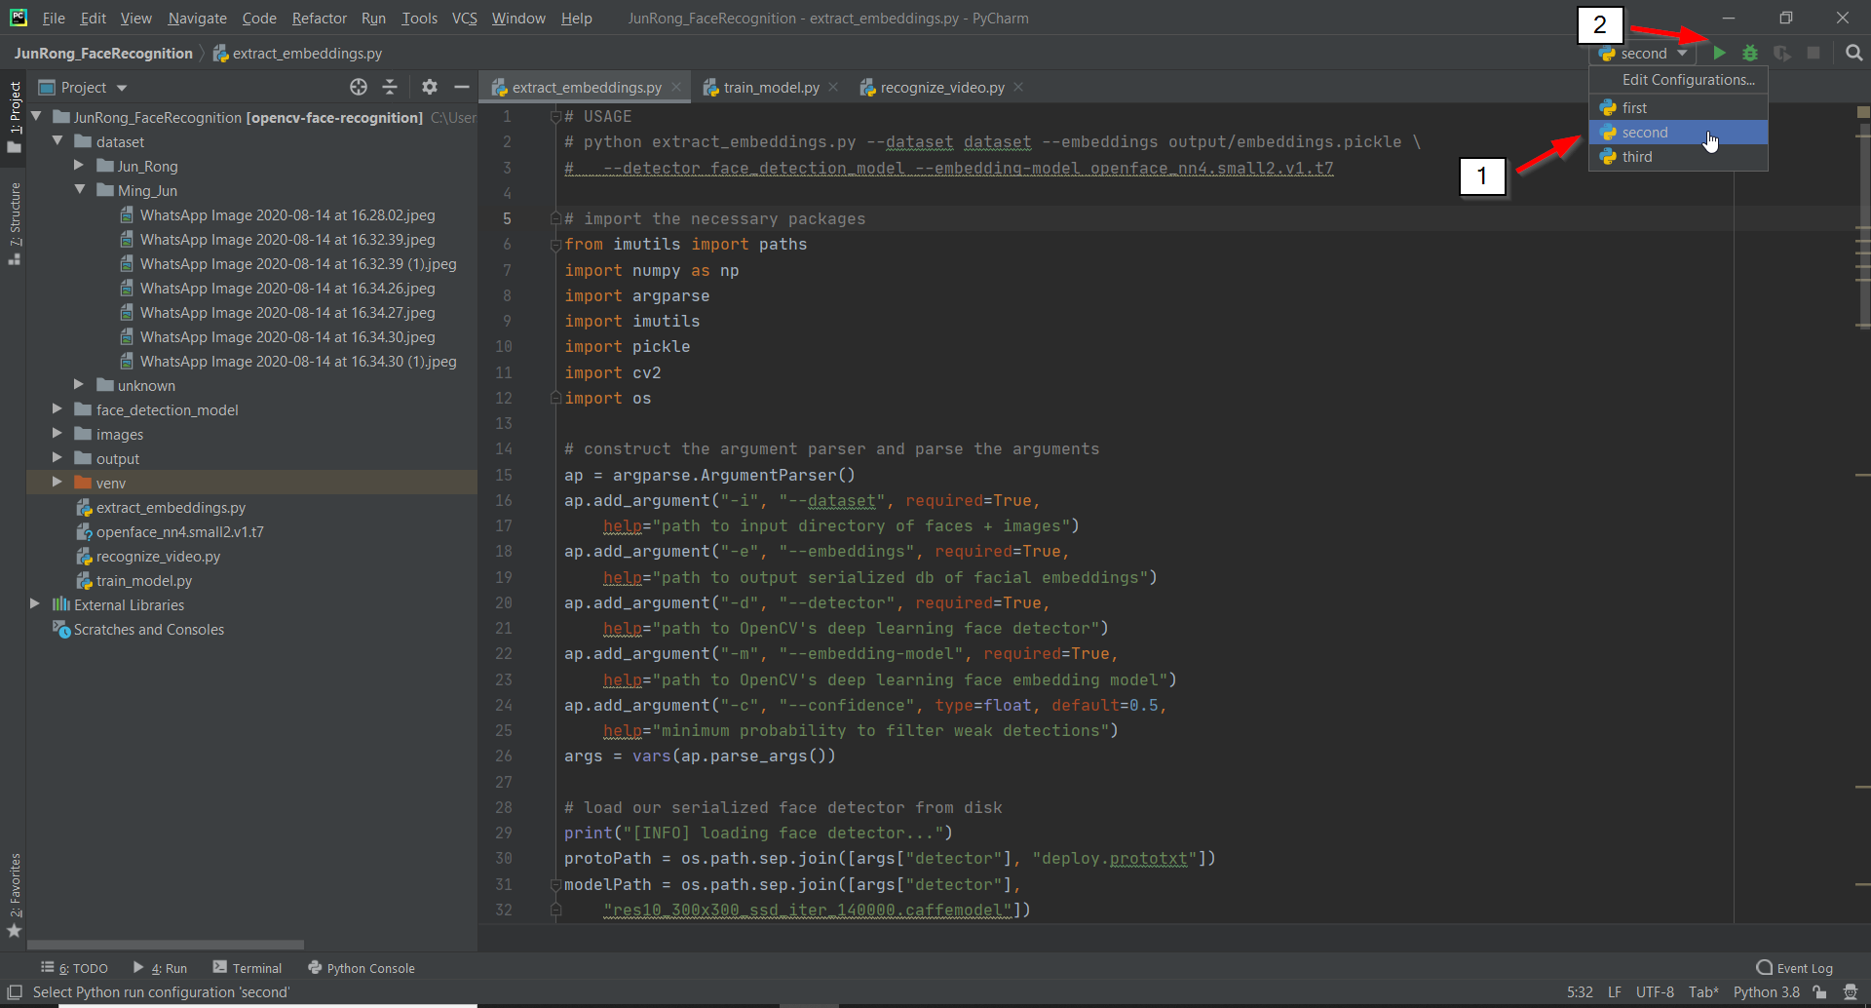

3.4 third

1. Select third.
2. Click the run button.

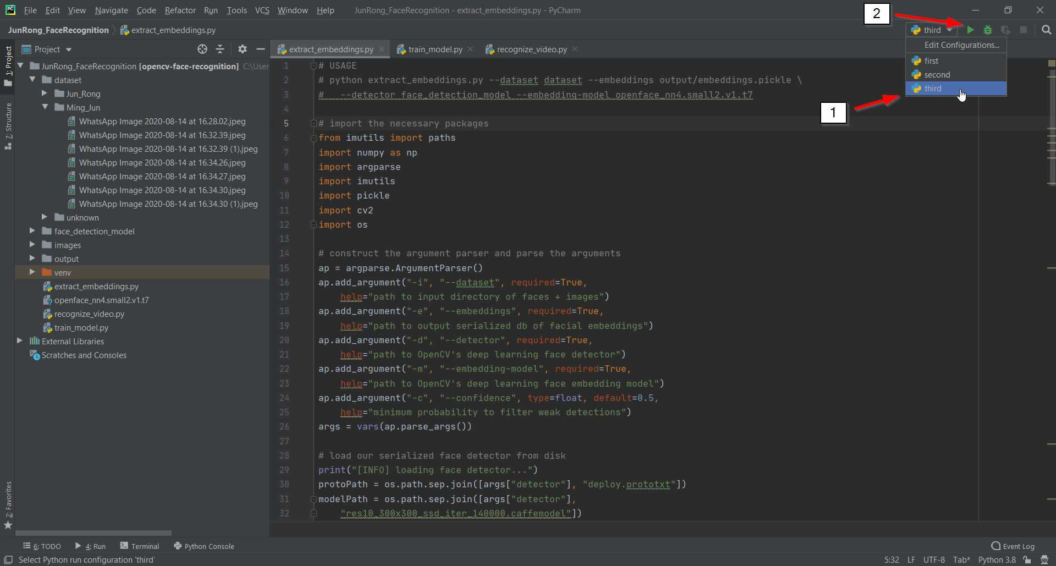

Sample output:

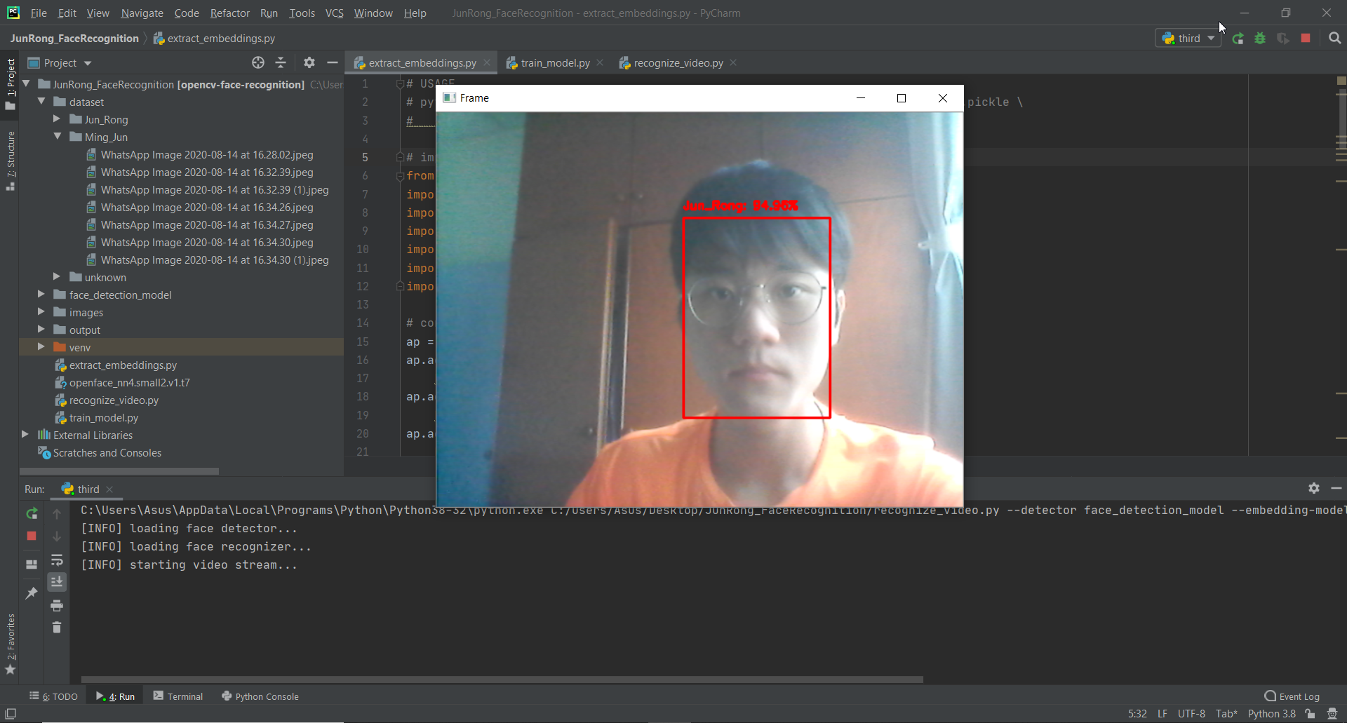

**4. Change/Add Dataset**

1. Right Click Unknown folder.

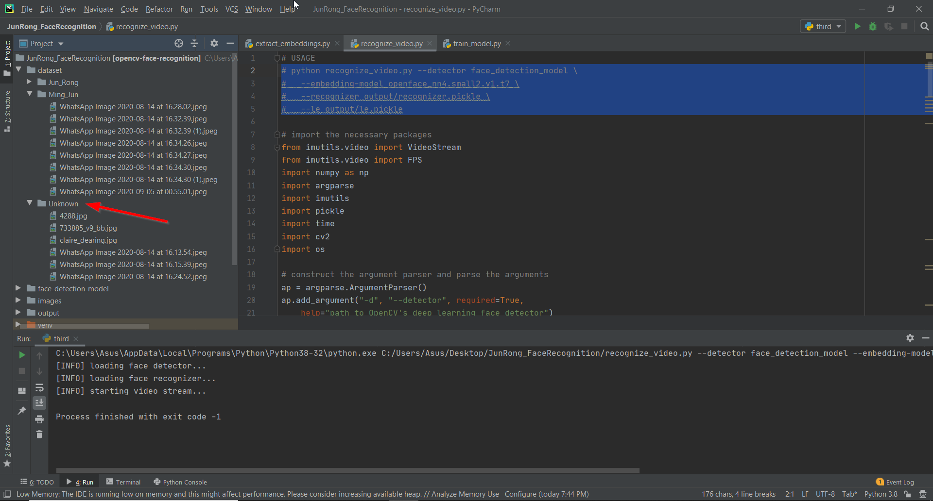

1. Select Refactor > Rename.

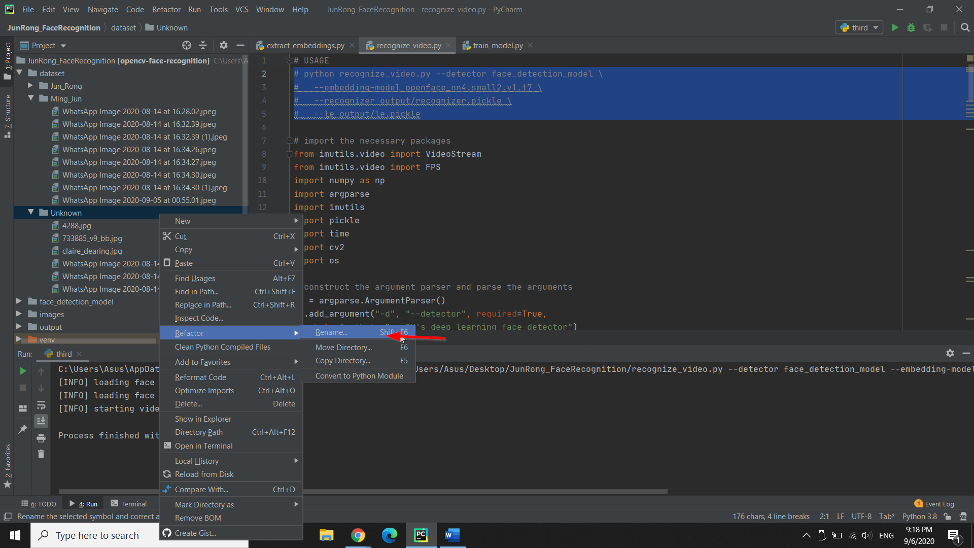

1. Enter any name in the column provided (i.e Dr_Christopher).

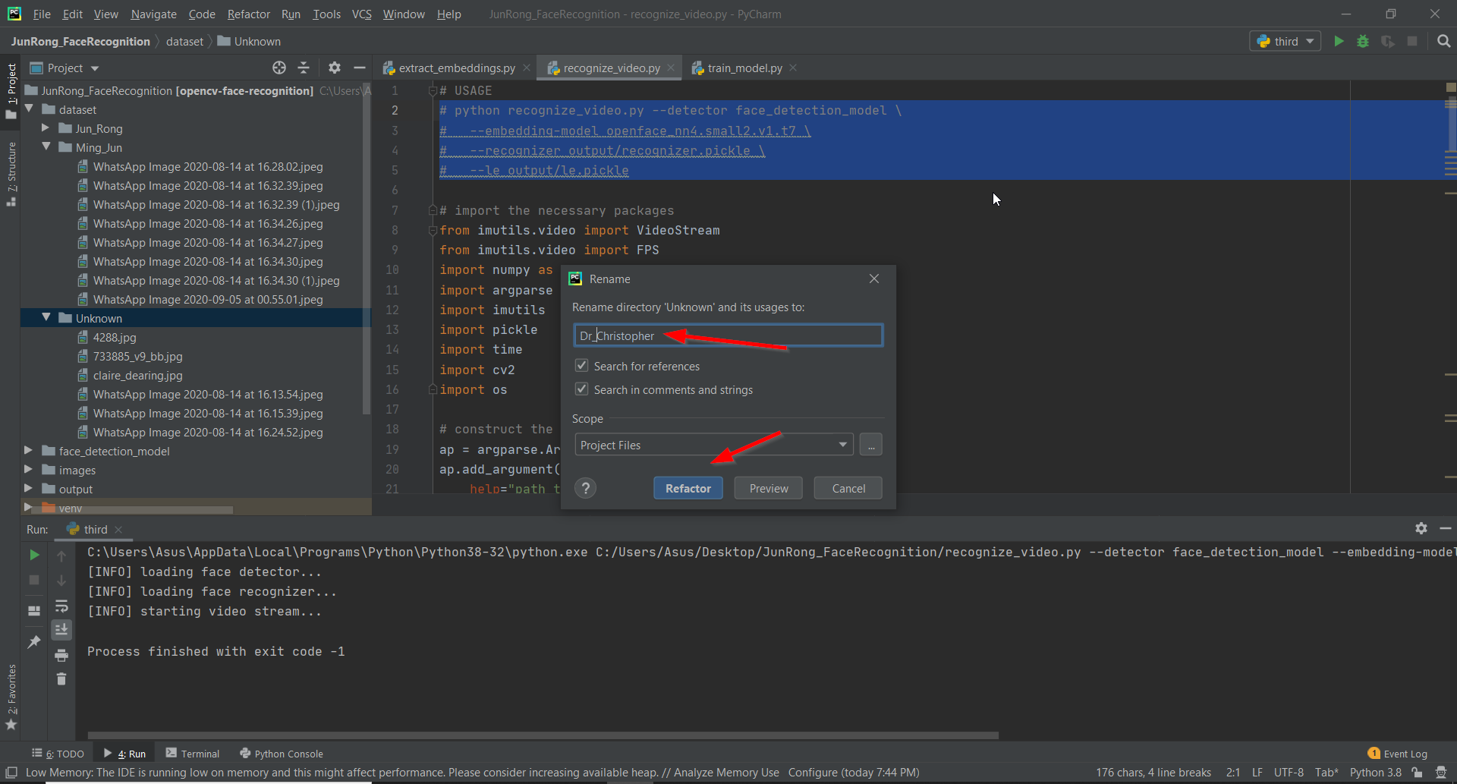

1. Under Dr_Christopher folder, remove all the images and add in your own datasets/faces. Please add at least **30 photos/faces** in order to get a more accurate result.

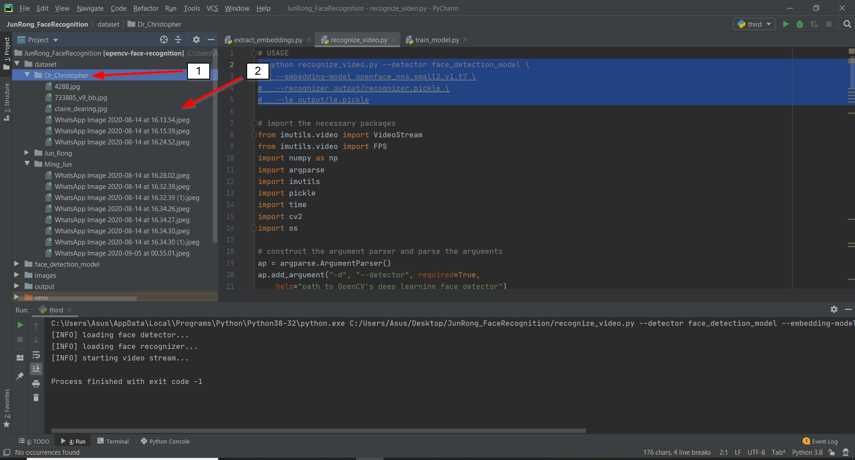

-----------------------------------------------END OF USER MANUAL-----------------------------------------------

Should you have any questions, please feel free to contact me at +6011-23177422.